Diagrama de solución
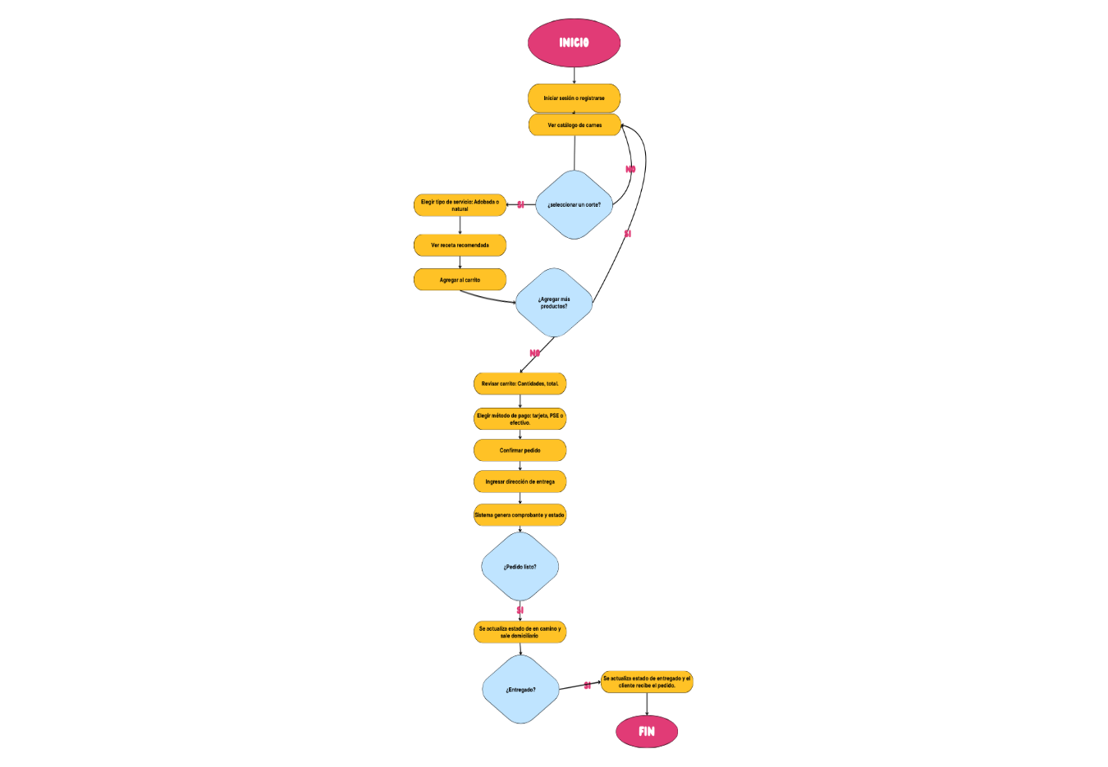
Link de Canva: https://www.canva.com/design/DAG0v54W7KA/Zt3hFRMkmrtc_VLRNH8c6w/edit?utm_content=DAG0v54W7KA&utm_campaign=designshare&utm_medium=link2&utm_source=sharebutton

